Public Works in Japan:
Leading the Way Again -- Japanese Government Embraces Critical Chain
SAPPORO, JAPAN -- On November 26-27, 2008, the Japanese Government's
Ministry of Land, Infrastructure and Transportation (MLIT) sponsored a
"Win-Win-Win" Public Works conference in Sapporo, the largest city
on the northern island of Hokkaido.
The purpose of the conference was in part to announce that the
Theory of Constraints application for projects, Critical Chain Project Management
(CCPM), has from here forward become the de facto standard
for all Public Works Projects in Japan.
Invited guest David Updegrove of Afinitus Group, LLC was introduced
to the conference as "the Sensei who brought Critical Chain to the
Japanese construction industry."
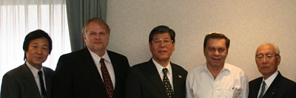

Pictured above from left: Kiyoshi Okudaira, Director General Hokkaido MLIT;
Dave Updegrove, Principal, Afinitus Group;
Hiroaki Tanaguchi, Vice Minister, MLIT Japan;
Dr. Eli Goldratt; Tadashi Onishi, former Managing Director, Toyota Motors

A single successful pilot project on Hokkaido in 2005 led to 15 more successful Hokkaido pilots in 2006. In 2007, based on the

impressive results of the pilot projects, CCPM began to be rolled out voluntarily across Japan, with 2523 projects using the TOC approach. In 2008 the number rose to over 4000 projects, leading to the government announcement that CCPM should be used on all projects henceforth (approx. 20,000 projects per year).
The keynote speaker for the conference was Dr. Eli Goldratt, creator of the Theory of Constraints and Critical Chain Project Management.

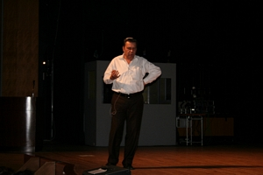
Dr. Goldratt speaks to 550 Win-Win-Win conference participants.
The conference title, "Win-Win-Win Public Works" refers to the significant benefits in both project lead time and money that Critical Chain brings to everyone involved -- the construction industry, the taxpayer, and the government. On the government's part, they have pledged "One Day Response" to construction company questions or problems concerning tasks on the Critical Chain. To date, this combination has led to average project durations being cut by 20-30% or more, with some companies able to do twice as many projects in the same timeframe with the same resources.

