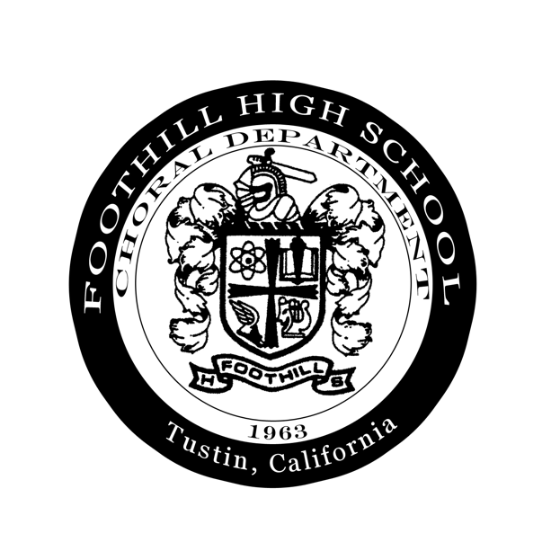

Dear [insert name],

This April, I have an opportunity to participate in a once-in-a-lifetime experience: performing at Carnegie Hall in New York. But I need your help to do so.

After a rigorous audition process last spring, I was honored to be selected as a member of Foothill High School’s prestigious [insert choir]. The choir performs throughout Southern California, and also receives invitations to perform at out-of-state venues.

My choir, along with the [insert other choir], has been invited to sing in an honor choir in the world-famous Carnegie Hall, as well as compete in the Heritage Festival at Riverside Church. While in Ney York City from April 4th - 8th, we will have the opportunity to visit historic landmarks and attend a Broadway musical. There’s one catch, however—the cost of this trip must be completely financed with fundraising and donations from family members, friends, and other supporters of the Foothill Choral Program in order for my choir to attend the trip.

For the past several months, I have been raising funds toward this trip, which will cost $1800 per student, not including the cost of food. I have personally committed to raising a total of $[insert amount], and have raised $[insert amount] to date.

Your donation of $25, $50, $75, $100 or more will bring me closer to my goal and this incredible opportunity. To submit your tax-deductible gift, all you need to do is complete the enclosed form and return it with your check, made payable to FHS Choir (please do not write my name anywhere on the check, only on the form). There’s even a credit card option if that’s more convenient for you.

By being part of the Foothill Choral Program, I’ve learned about the importance of integrity, hard work, excellence, and teamwork. The program has provided me with an outlet for my creative energies, and I have formed friendships that will last a lifetime. I anticipate that this trip to New York will be a major highlight of my high school journey. Please consider taking part in making this journey successful by making a gift to support my trip today.

Best regards,

[insert your name]
[insert phone number]

Tax-ID: 91-2171069
19521 Dodge Avenue | • Santa Ana, California 92705 • (714) 730-7464 ext. 406 • www.foothilchoir.com

Please indicate your New York donation preference below.
Foothill High School Choral Program
Name of Student
Yes, I will help sponsor ___________________________ with a gift of:

Donation Preference: $25 $50 $75 $100 Other: __________
I will donate online at www.foothillchoir.com
My check, made payable to FHS Choir is enclosed
Please charge my credit card:
Visa or MasterCard
Name on Card: ______________________________
Credit Card Number: _______________________________ Expiration Date _____ / ______
3 Digit Verification Code _________ Signature _________________________________

Name _________________________________ Email ___________________________________
Address _______________________________________________________________________
City _______________ State __________ Zip _____________

- Please return your gift by Friday, February 22nd
- The amount of your gift is confidential and will not be disclosed to the student you are sponsoring

Return this form and tax-deductible donation (if by check) to:
Foothill High School c/o Chelsea Dehn
19521 Dodge Avenue
Santa Ana, CA 92705

To donate online or find more information, visit:

www.foothillchoir.com

Tax-ID: 91-2171069

