|  |
| --- |
|  |

**BEES Seminar series s1 2013**

**Dr Joe Miller**

**Centre for Australian Biodiversity Research**

**CSIRO Plant Industry**

**University of Washington, Seattle USA**



***The Natural History of Acacia***

**Abstract**

*Acacia* is the largest plant genus in Australia with over 1,000 species which are found in most ecological niches throughout the continent. *Acacia* diverged from its most recent common ancestor around 30 mya but has gone through a later rapid radiation coincident with the aridification of the Australian continent. This diversification has resulted in an extraordinary amount of morphological diversity, especially in vegetative traits. This seminar will describe the evolution of *Acacia* with an emphasis on the spatial distribution of the diversity as well as changes in key morphological features. The seminar will also discuss analysis of *Acacia* with allied organisms such rhizobia and insects.

**Wednesday March 6th 3−4 PM in Biomed B**

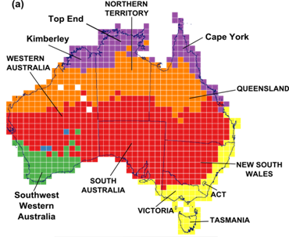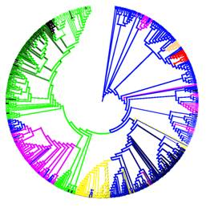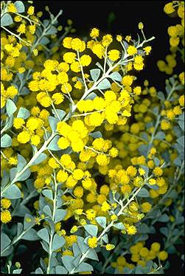

**All Welcome**

**Refreshments afterwards**

**All welcome. Refreshments afterwards!**