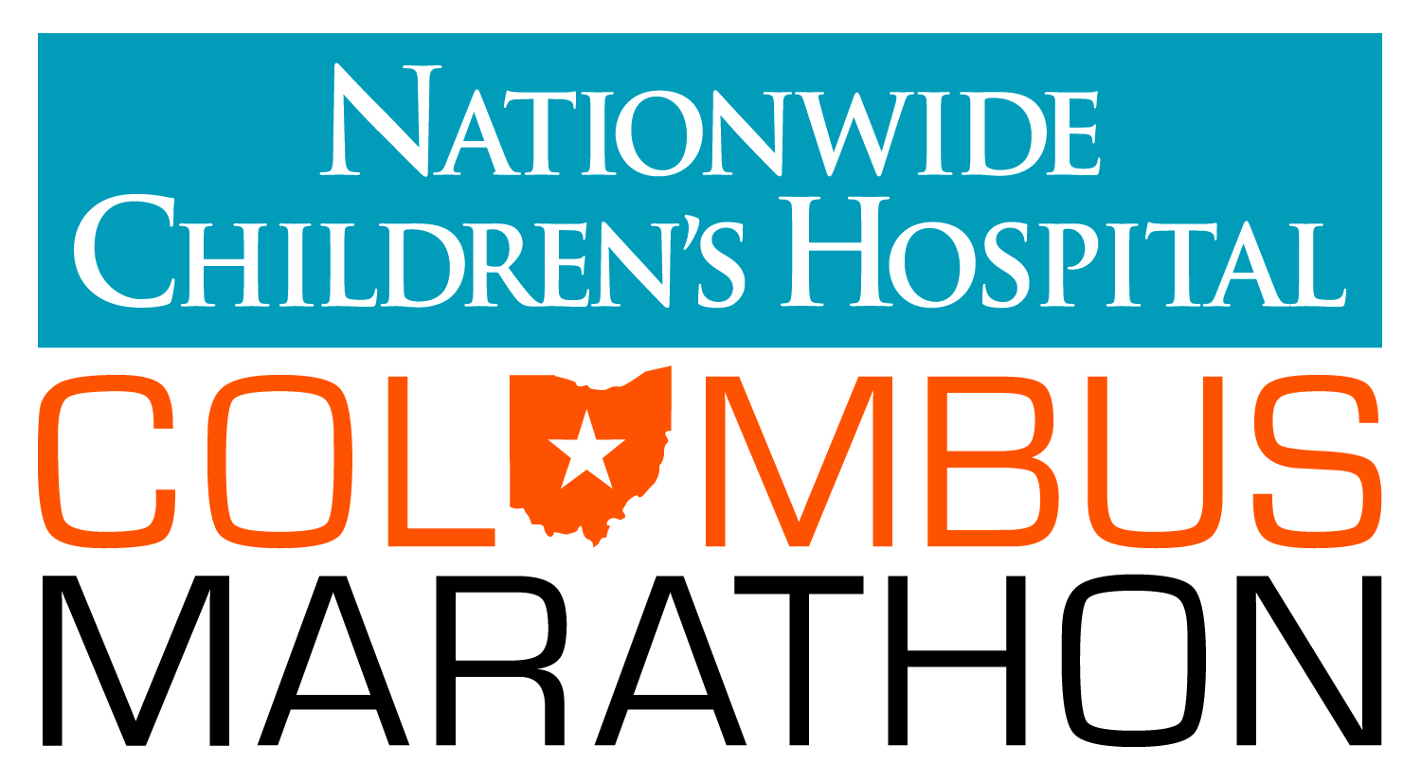

FOR IMMEDIATE RELEASE FOR MORE INFORMATION:
Oct. 17, 2012 Sarah Irvin Clark, Irvin PR, 614.296.4057 (cell)

Nationwide Children’s Hospital Columbus Marathon &
1/2 Marathon Sells Out For Sixth Straight Year!
33rd Annual Race Sells Out with Largest Marathon Field in Event History
(COLUMBUS, OH) – All 18,000 slots are filled for the Nationwide Children’s Hospital Columbus Marathon & 1/2 Marathon that will take place this Sunday, October 21, 2012. This marks the sixth straight year the event has sold out and the largest full marathon field in the history of the event.

“We knew the partnership with Nationwide Children’s Hospital would be a big deal,” said Darris Blackford, race director for the Nationwide Children’s Hospital Columbus Marathon & ½ Marathon. “There is so much excitement and buzz about this event around the nation and that’s evidenced by the fact that we have a record number of 7,000 participants in the full marathon -- breaking our record of 6,500 marathoners that was set in 1995 when the entire running world was trying to qualify for the 100th Boston Marathon.

The newly re-named event will highlight the beneficiary of the marathon – Nationwide Children’s Hospital. Other new additions to the 2012 event are:
- “Patient Champions” – Each of the 26 “Miracle Miles” will be dedicated to a current patient of Nationwide Children’s Hospital. These children include: 11-year-old Maggie, who suffers from epilepsy and a form of autism; Sophia, born with five holes in her heart; and Toby, who has Spina Bifida and hydrocephalus; among many others. The Patient Champions will be on the course on race day to cheer on the participants.
- The Columbus Bicentennial will be celebrated when every 200th finisher will receive a prize of dinner for 10, courtesy of Chipotle. Additionally, Columbus is hosting some athletes from our sister city in Dresden, Germany to run in the race. Concurrently, Dresden will welcome 20 of our athletes to participate in their marathon, half-marathon and 10K event, held on the same day.
- Funds raised for Nationwide Children’s Hospital: The Columbus Marathon has implemented a match up to $100,000 in funds raised, which will be directed to Nationwide Children’s Hospital. Additionally, hundreds of “Children’s Champions” will run to raise funds that will be given to the life-saving work of the hospital.
- Ohio Stadium: For the first time ever, the marathon course will take runners and walkers through Ohio Stadium – through the home tunnel, across the south end zone and out the opposing team’s tunnel.
The Nationwide Children’s Hospital Columbus Marathon and ½ Marathon will start near the intersection of Broad and Third Streets in downtown Columbus at 7:30 a.m. on Sunday, October 21 for wheelchairs, walkers and runners. The course will be open until 3 p.m.

###

About The Nationwide Children’s Hospital Columbus Marathon & ½ Marathon
The 33rd Nationwide Children’s Hospital Columbus Marathon & ½ Marathon will be held on Sunday, October 21, 2012 and will feature a sold-out field of 7,000 full Marathoners and 11,000 1/2 Marathoners. The Nationwide Children’s Hospital Columbus 1/2 Marathon is among the 25 largest half marathons in the United States and the Columbus Marathon is one of the top marathons to qualify runners for the Boston Marathon. For more information, visit www.columbusmarathon.com or call 614.421.7866.

About Nationwide Children’s Hospital
Nationwide Children’s Hospital is honored to serve as the title beneficiary of the Nationwide Children’s’ Hospital Columbus Marathon & 1/2 Marathon. Each mile in this year's race is represented by a patient at Nationwide Children's. These patients and their families will be along every mile of the course to cheer on participants and serve as a visual reminder of how the marathon is helping ill and injured children. Children’s Champions are participants who chose to run, walk or cheer for the marathon or 1/2 marathon while fundraising for Nationwide Children’s Hospital. As a Children’s Champion, these 800-plus individuals are reaching beyond personal training goals to support another mission. To cure, to mend, and comfort each child that walks through the doors of Nationwide Children’s. Their fundraising efforts help provide every child with the highest quality of care, regardless of the child’s diagnosis or the family’s ability to pay. The marathon and 1/2 marathon may be full, but there’s still time to become a Children’s Champion. To learn more about the Patient Champions or fundraising efforts visit nationwidechildrens.org/childrens-champions.

# # #

