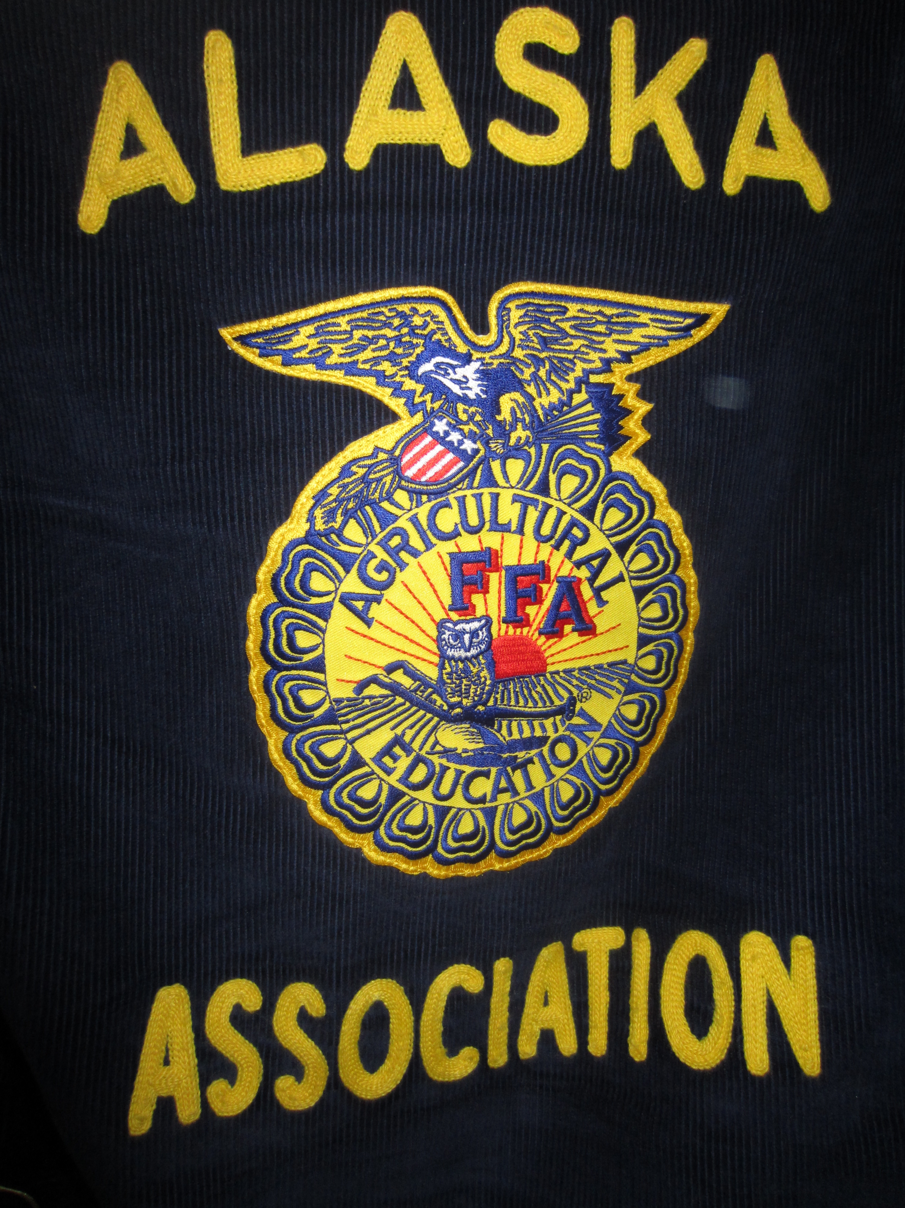

Alaska FFA Association:
2013
State Officer Application

Dear FFA Members and Parents,

First of all, congratulations on reaching this point in your FFA career. We applaud you and appreciate your dedication to the organization.

This packet has all the information needed in order to apply for a position as an Alaska FFA State Officer! Please review the application closely – not only to fully complete the application, but also to understand the expectations and responsibilities of a State Officer. The position of State Office is an honor that we take very seriously.

The role of a State Officer is rigorous and extensive. As a State Officer, you will be expected to execute the State FFA Program of Activities (including conducting chapter take-offs; advocating for agriculture, FFA, and agricultural education; working closely with stakeholders and sponsors; attending planning meetings; and planning and executing the Alaska FFA State Convention) and receive the proper training to accomplish such activities. All officers are expected to be active members of their chapter and to help the chapters of Alaska execute their own Program of Activities. State Officers shall build and maintain close relationships with FFA members across Alaska, and help inspire, motivate, and education them to participate in FFA and agricultural/natural resource education programs that will further their potential in premier leadership, personal growth, and career success. State Officers will also be expected to, at all times, be a positive image for Alaska FFA and as a leader among American youth.

On a more regular basis, State Officers will be expected to respond to and participate in weekly group emails with fellow State Officers and State Advisors. In addition, there will be monthly teleconferences State Officers will be required to attend. Prompt responses to emails and presence at teleconferences are essential because these will be the main modes of communication.

Alaska FFA will pay for travel to and from each FFA event the State Officer is required to attend and provide meals and lodging. In many cases we ask your students to find their own means of transportation, in which case we will pay $.30 per mile to cover gas costs. In addition we will purchase a new FFA jacket for each officer as well as some other state officer gear. The only exception to this is the trip to National FFA convention. We ask the State Officers to fundraise with their home chapter and pay for that as they have in the past, whether it’s as a chapter or as individuals.

The role of a State Officer is not only work, but has many benefits. It leaves an individual with inseparable friendships, skills important for the rest of your life, and experiences you can’t find anywhere else.

If you have any questions about the role and expectations of a State Officer, please do not be afraid to contact the Alaska FFA State Staff.

Amy Harmon Rayne Reynolds
Co-State Advisor Co-State Advisor
aharmonffa@gmail.com rayne@alaskaffa.org
(907) 982-2310 (907) 953-0093

Alaska FFA Year at a Glance (2013-2014)
Bold Items Require Attendance By All State Officers. Dates include travel days
Some items are listed for informational purposes ie. Fairs, state officers are not expected to attend.

May 28-June 2 BLAST OFF TBA
July 7-13 NLCSO Washington State
July 22-29 State President’s Conference Washington DC
Aug. 2-11 Tanana Fair Fairbanks, AK
Aug. State Officer Training Camp TBA
State Sponsorship Day Anchorage, AK
Aug 22-Sept 2 Alaska State Fair Palmer
Oct. Palmer Harvest Dinner Palmer, AK
Sept.-Nov. Chapter Take Offs
Homer Homer, AK
N. Pole & Effie Kokrine Fairbanks, AK
Delta Delta, AK
Kodiak Kodiak, AK
King Career Center Anchorage, AK
Palmer Palmer, AK
Mat Su Home school TBA
Sept.-Dec. Membership Rosters
Sept-Dec. Sponsorship Visits TBA
Oct. 30-Nov. 2 National Convention Louisville, KY
Teacher Training Program Anchorage, AK
Jan-March Chapter Development Visits
March 6-9 State Convention Planning Mtg. TBA
March 15 State Convention PREREGISTRATION DUE
April 1 State Convention REGISTRATION DUE
April 1 State Officer Applications Due
April 1 Proficiency Award Applications Due
April 1 State Degree Applications Due
April 23-26 STATE CONVENTION TBA
Alaska FFA State Officer Application Check-Off Sheet

- Complete State Officer Candidate Application

- Complete Delegate Interest Form

- Signed and Completed Prerequisites/Expectations/Commitment Form

- Resume

- Cover Letter

- Essay

- Letters of Recommendation (2)

- Transcript

- Complete Signature Page

- Complete Parent Information Sheet

FFA Officer Application additional information

Please complete application and mail to:

Alaska FFA Association

101 West Arctic Ave.

Palmer, AK 99645

MUST BE POSTMARKED BY: APRIL 1, 2013

Please note: High School seniors are encouraged to apply. Applicants that are a high school senior at time of application may serve as a State Officer. It is not required that a State Officer be in college, however it is suggested. If a student is serving as a state officer while in college, it must be in Alaska.

If you have any questions PLEASE call Rayne Reynolds (907) 953-0093
State Officer Candidate Application

Name ___________________________________________ Phone No._____________________
Address (Complete) ______________________________________________________________
City ______________________________________ State AK ZIP ____________________
FFA Chapter ____________________________________ Birth date _______________________
Parents' Names and Phone Numbers _________________________________________________
School Address __________________________________________________________________
School Telephone Number (907)___________________ Fax Number_______________________
Chapter Advisor(s) _______________________________________________________________
Year of high school graduation ____________ Current high school G.P.A; (4.0 scale) __________
How long have you been an FFA member? (Years) ___________
Email Address ___________________________________________________________________
Name of College / University/ Technical School (Planning to Attend) _______________________
Have you received or applied for your State FFA Degree? ___________ If yes, When? _________
Career Objective(s) _______________________________________________________________

Do you have a valid Drivers license? ______________________________
Do you participate in school sports? ____ Y ____N If yes, list the sports and dates of their seasons, including major tournaments (such as Boroughs, State, etc.).
_________________________________________________________________________
_________________________________________________________________________
_________________________________________________________________________
This application has been received _________ and has been: Accepted |__| Declined |__|
(Date)

By the Alaska FFA State Advisor: ___________________________________________
(Signature) (Date)
Delegate Interest Form

Every year the Alaska FFA Association has two delegates. These delegates have the opportunity to attend a training put together by National FFA as well as vote on National FFA issues at the National FFA Convention.

The National FFA training is called State Presidents Conference (SPC). It occurs over the summer (dates in the “Alaska FFA Year at a Glance”) and is attended by two State Officers from each state, Puerto Rico, and the Virgin Islands. It reviews all delegate issues that will be considered at the National FFA Convention and individuals will be placed on committees working with National FFA issues.

Issues reviewed at SPC will be voted on at the National FFA Convention. The delegates MUST plan on attending the National FFA Convention a few days early (2 or 3) since committees formed at SPC will be finish their work and further training for delegates will occur. Following committee work and training, delegates will attend business sessions and vote on National FFA issues.

Being an Alaska FFA delegate is an honor. It provides the opportunity to impact the National FFA Organization and to represent the Alaska FFA Association on a national level. It is an important position, but is also a treasured experience.

We want to ensure that the individuals selected to attend the National FFA training also commit to attend the National FFA Convention to represent the Alaska FFA Association in voting on National FFA issues. It is important to remember that the Alaska FFA Association, while able to cover the expenses to attend SPC, is not guaranteeing the expenses to attend the National FFA Convention. Delegates would need to be able to cover this expense.

Are you interested in serving as an Alaska FFA delegate? _____YES _____NO

At this point in time, are you able to commit to attend both SPC and the National FFA Convention? (You maybe in interested but not able to commit yet) _____YES _____NO

If you ARE interested, but NOT able to commit, what is the reason for this?

Prerequisites/Expectations/Commitment Form

Please check all that apply

- Has earned or applied for the State FFA Degree;
- Is at least a junior in high school and has been a member of FFA for two academic years
- Has an active SAE, listed here: ___________________________________________
- 17 years of age by the 1st of July of election year;
- Member of an active chapter and commitment to maintain membership through year of service;
- Has a cumulative GPA of at least 2.5 at the time of application and commitment to maintain such GPA throughout year of service (failure to do so will result in forfeiture of State Office, if elected);
- Commitment to attend required events (indicated in “Alaska FFA Year At A Glance”);
- Willing to commit the entire year to service of the Alaska FFA through FFA State Officer activities and duties, even to the exclusion of some other preferred activities;
- Willing to become knowledgeable of Alaska’s agriculture, natural resources, and education;
- Willing to develop self into an effective leader through trainings, preparation, practice, and constructive criticism;
- Will strive to improve ability to carry on meaningful and enjoyable conversations with individuals of all ages;
- Will keep self up to date on current events regarding the industries that feed, fuel, and finance Alaska;
- Will forego all alcohol, tobacco, and other drugs while serving as a State Officer;
- Will refrain from any unethical, illegal, or other inappropriate conduct that would be deemed improper of a State Officer, including but not limited to:
- inappropriate personal relationships
- any sexual behavior with other FFA members, including other State Officers
- malicious or otherwise ill-spirited behavior (spoken, written, or otherwise)
- inappropriate use of stature as an FFA State Officer
- Will maintain a proper image and demeanor as a role model for the FFA;
- Will treat all FFA members and chapters equally and respectfully at all times;
- Will keep official dress in a clean, professional manner to be ready at all times and wear official dress at all official functions;
- Will manage time and schedule properly to accommodate State Officer activities and responsibilities;
- Will communicate promptly and appropriately with State Staff and other State Officers;
- Will show enthusiasm and motivational support for the FFA;
- Recognize that my actions and attitude represents Alaska FFA even during my personal time, and will conduct myself in a manner that reflects my role as a leader and role model to others;
- Will commit to developing personal growth and safety plans with State Staff and other State Officers;
- Will always be truthful and honest in all of my dealings, both in and out of Office Dress

After reading the list of Alaska FFA’s expectations for you, please list any areas where you feel you may require training to help you commit to those expectations: ________

I have read and understand the above points. If elected, I will carry out my responsibilities in accordance with this statement and understand that the State FFA Executive Committee can remove me from office at any time if I do not adhere to these standards for State Officers or fail to fulfill my responsibilities.

Signed: _________________________________________________________________
(Signature) (Printed Name)
Resume

This is a document used to convey your most relevant experience related to the particular position for which you are applying. A resume is not a listing of your awards, achievements, offices, and memberships. Developing a successful resume involves evaluating your previous experiences and selecting a few that best convey your readiness to take on the requirements of the job. A successful resume will articulately convey your contributions as they relate to your involvement and experiences.

Things to consider including in your resume:
- Contact Information (name, address, email, phone number)
- Career Objective
- Education (no GPA)
  - High School name, city, state – years attended
- Two to three relevant leadership experiences (FFA, school, community)
  - Position, organization – dates held
    - Responsibilities
    - Major contributions
  - Membership, organization – dates of membership
    - Major contributions
- Two to three relevant professional work/experiences (SAE, other relevant work experience)
  - Position, organization, city, state – dates of employment
    - Responsibilities
    - Major contributions
    - Achievements
- Three to four relevant awards/recognition/achievements
  - Award title, warding organization, date awarded

Cover Letter

This letter is usually your first introduction when applying for a position with an organization. The letter of intent should give the reader a reason to look at your resume. Articulately and passionately address why you desire to serve as a State Officer in 500 words or less.

Things to consider including in your letter of intent:
- Date of letter
- Address to Alaska FFA Nominating Committee Members;
- Introductory paragraph
- Paragraph about your background or experience, which you believe qualifies you for the responsibility of State Office.
- One or two paragraphs addressing why you desire to serve as a State Officer.
- A concluding paragraph moving the reader to consider you.
- Appropriate close and typed name (as signature).

Essay

Please write an essay of 500 words or less titled “What I can do as a state officer in one year to engage FFA members in FFA activities and in the Alaska agriculture/natural resource industries.”

Letters of Recommendation

Two letters of recommendation must be submitted with the application. One of these two letters of recommendations MUST be from your chapter advisor.

Transcript

Must submit one official copy of your most recent high school and/or university transcripts. This can be requested by asking your school’s academic counselor.
Signature Page
Applicant’s Name: ________________________________________________
Student | I understand that as a State FFA Officer I am required to devote 50-75 days during the year to serve the Alaska FFA Association. I will devote the time needed to carry out the duties of a state officer. I understand that I may have to adjust my current sports, extracurricular, and employment activities to fulfill the responsibilities as a state officer. I have prepared this application myself and certify that all information contained herein is true, complete, and accurate.
 | Signed _______________________________________, Applicant Date _____________
Parent
 | I support my child completely in fulfilling the requirements of the State FFA office and agree that he/she will have the time necessary to carry out the duties. I have read this application and all information is accurate. I understand the expectations and benefits of this activity and allow my child to participate.
 | Signed _______________________________, Parent or Guardian Date _____________
Chapter Advisor /President
 | We, the members of the ______________ Chapter hereby recommend ____________________ as a candidate for State Office and will assist him/her physically and financially when necessary in fulfilling the duties and obligations of this office and the activities of the Alaska State FFA including but not limited to attendance at the National Convention, Leadership Training and the Alaska State Convention.
 | Signed ______________________________, Local FFA President Date ________
 | As Advisor of the above candidate, I recommend the candidate for state office, in doing so I also agree to support the candidate throughout the term of office providing assistance and advice when needed to help him/her fulfill the duties of this office. I agree to ensure that the candidate have the resources necessary to be an effective officer.
 | Signed _______________________________, Chapter Advisor Date _
School Official | I understand the importance of the role of the FFA State Officer and recommend the candidate for such responsibility. I understand that the role of the FFA State Officer is a highly respected and honored office that is recognized by local, state, and federal governments as well as industry. I understand that the student will, on occasion, be required to attend State, Regional and National meetings. I agree to support this student and uphold the activities of the Alaska State FFA and provide assistance/guidance to the candidate when needed to allow him/ her to successfully complete the term of office while the student is enrolled in a school under my supervision.  Signed _________________________, School Principal (DEAN) Date _____________  Signed ________________________, School Activities Principal Date _____________
Parent Information Sheet

Dear Parent(s),

First of all, we would like to express our gratitude and sincere respect toward you and your child. What your child has already given to the program up to this point has made a difference in the lives of many members and your support throughout their FFA career has made that possible.

Becoming a State Officer requires a lot of time and dedication. While most of the efforts must come from your child, your support and understanding in their endeavors as well as our understanding of your child’s restrictions and availability is essential. In order for us to better understand your child’s situation and to assure you are aware of the commitment your child is making, we would like to ask you to please fill out the survey below.

We appreciate your time and understanding. Once again, thank you for your continued support of your child throughout their FFA career. If you have any questions, please do not hesitate to contact the Alaska FFA State Staff.

Amy Harmon Rayne Reynolds
Co-State Advisor Co-State Advisor
aharmonffa@gmail.com rayne@alaskaffa.org
(907) 982-2310 (907) 953-0093

- I have read and understand the events my child will be expected to attend (found in “Year at a Glance”)
- I have read and understand the financial costs expected of my child (none expect for National FFA Convention if your child so chooses to attend)
- I have read and understand the time commitment involved in being an FFA State Officer (found in the letter to member and parents and “Year at a Glance”)
- I have discussed with my child their running for this position, the financial obligations, and the expected time commitment of a State Officer

- Has your child expressed interest in serving as a National Delegate? Yes/No (circle one)
  - If so, do you understand the financial obligation of your child to attend National FFA Convention? Yes/No
  - Are you going to be assisting your child in these financial obligations? Yes/No
  - If no, does your child have the means to obtain these funds? Yes/No
- Being a State Officer requires a lot of travel. Does your child have a driver’s license? Yes/No
  - If so, do they have access to a vehicle? Yes/No
- Are you comfortable with them driving or riding long distances to FFA events? Yes/No
- Does your family hold any religious or spiritual beliefs that may affect your child’s availability during the year? Yes/No
  - If so, please describe here: ________________________________________________

______________________________________________________________________
- Does your family have any vacations or other travel plans for the coming year? Yes/ No
  - If so, what dates will your child be gone? _____________________________________

_____________________________________________________________________________________
(Signature of Parent/Guardian) (Date)

_____________________________________________________________________________________
(Signature of Parent/Guardian) (Date)

