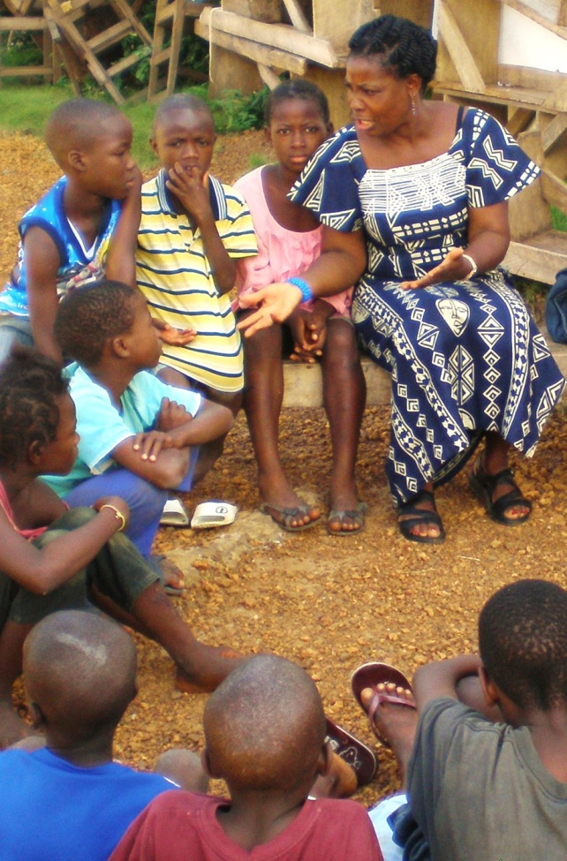
Summary
The We Have Hope pilot project in Liberia was extraordinarily successful; generating sustainable local initiatives toward supporting hurting children and significant strides in learning for the project and process overall. A total 42 trainees successfully completed the 2-week training course. Through the help of the local church and in-country partnerships, candidates for a Implementation Support Team (IST) were selected and invited to the participate. These individuals helped to lead small groups throughout the training and closely connected with trainees in their same geographic location. They have committed to take responsibility to support the trainees in their area as they step out to implement what they have learned. Using a before and after assessment, Participants gauged their learning in 30 different learning areas. On average, trainees report 38.4% increase to their base level or previous knowledge in each of these 30 learning areas. Reports of support groups running and utilization of the material have already been submitted.

Successes

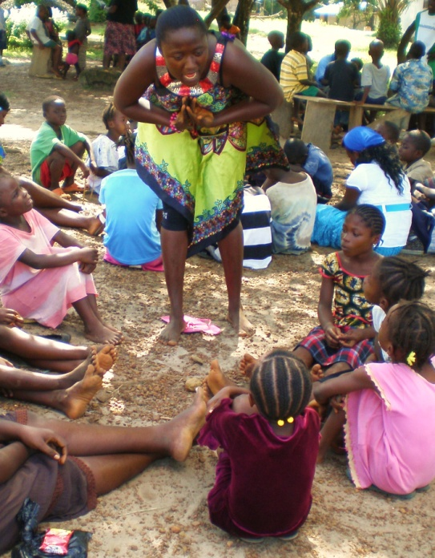
Selection Process

Though the selection process did not start in an ideal way, the end result was a real success. We had approximately 80 individuals apply to be a part of the training. The applications were screened by the IST, WHH facilitators and other local leaders. A total of 52 applicants were selected from a variety of locations. The screening process resulted in the best quality candidates as well as diverse representation. 16 different churches were represented from 3 different provinces; both inner-city and suburban Monrovia was represented. All trainees accepted regularly work directly with children or supervise those who do. They were all committed Christians, understand work with hurting children to be a part of their life calling, were English speaking and literate. The nearly all were high school graduates and several had or were studying at a Tertiary institution.
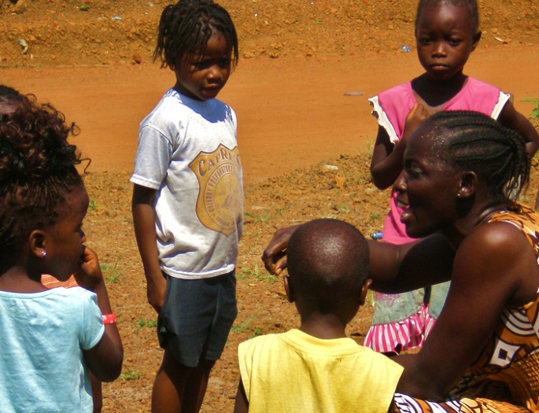
Though many (even within the IST) did not understand why we would turn people away (as they were paying something to attend the training) selection was a critical part of the process and resulted in greater commitment from those accepted; greater capacity to facilitate trust and close relationships within the group as well as a greater level of responsiveness and learning. We were able to train from diverse professional fields; School Teachers, Children’s Pastors, Sunday School Teachers, Social Workers, Community Youth Workers, School Principals, and Senior Pastors were all represented in the training.

Practical Application & Compassion Day
Trainees were given 15 hours to practically apply their new skills and tools with children directly. Ten of these were done in small groups utilizing the curriculum directly. Five hours were completed while facilitating a Compassion Day in at 3 different work-sites where children from the community were able to serve their local churches, clinic and hospital. During these practical sessions trainees were observed and given a 360-degree evaluation which included an individualized summary of their strengths and weaknesses based on their self-evaluation and the feedback given by their peers and the WHH facilitators. This feedback and the opportunity to use the learning in hands-on practical ways eliminated many barriers to implementing the learning post-training as we were able to discuss the challenges they faced after each practical session. These sessions were also rated very highly by all trainees.

Subject Specific Learning Enhancement

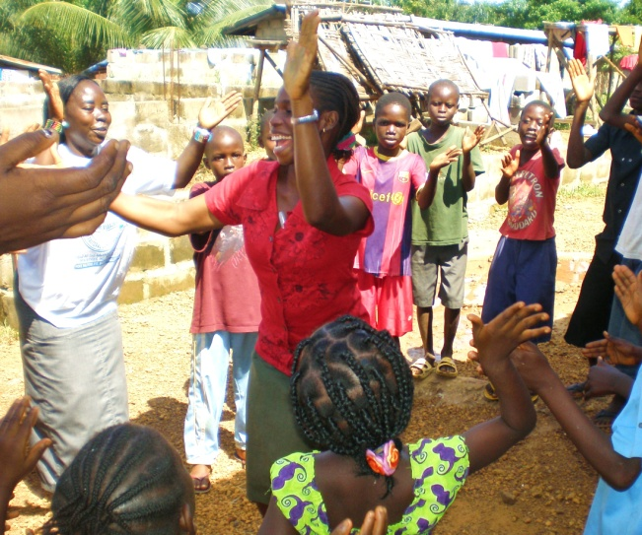
As mentioned above trainees rated their own learning during the two weeks. Overall, trainees reported an average of 38.4% increase in learning from their previous knowledge in helping children through hardship.

The greatest jumps in learning were in understanding the difference between shame & guilt, non-shaming discipline techniques and techniques in Play & Expressive Therapies. On average, these showed a 46% increase in learning from trainees’ previous knowledge in the area. Additional learning significant jumps were found in the following topics; Organized Play & Group Games, Service as Means of Healing, The Neurology of Trauma, Personal Boundaries, Healing through Play and Dealing with Anger. The average learning increase here was 42%. The overall average increase in learning was 38.4% in all 30 learning areas. The greatest amount of learning was in Understanding Trauma (40% increase on average) and Positive Discipline (45% increase on average).
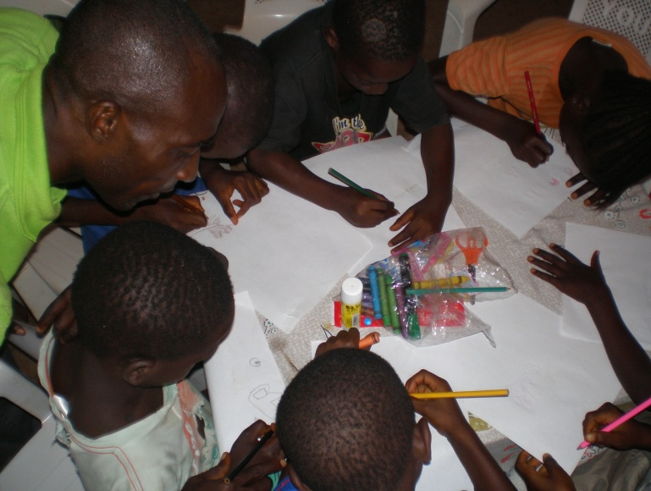
Implementation Support Team (IST)
The Implementation Support Team was the greatest key in the process. This was the most important key piece of learning. The training was considerably more effective when done with these small group leaders. The trust and respect developed by the trainees toward the IST members directly carried over into the post-training accountability and support role that IST members had to step into. Throughout the 14 days a clear leader emerged from the team who felt called to coordinate the IST. This was also an essential component. Some of the top level IST members facilitated aspects of the training in the last few days, leading nearly all of training time on the final day and running the closing ceremony and graduation of successful trainees.
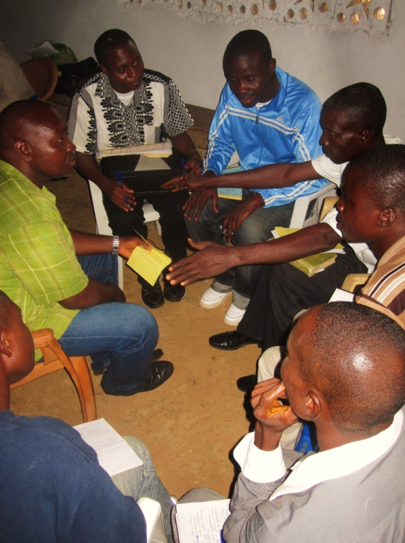
Trainees were not given certificates but rather incentives. WHH Small Group supply kits were given to the IST to be distributed to trainees who had started a group and met regularly with children for a full month post-training. The IST began their distribution of these kits from August 11th and are continuing with site visits, support and kit distribution each weekend. Those trainees who continue to serve children for a minimum of 6 months each week will be invited to a celebratory reunion dinner where they will receive their certificate as a We Have Hope Facilitator as well as further encouragement through the testimonies of others from their training group.

Momentum

All participants created their own Implementation Plan detailing how they would use the training in the community they are currently working or living in. The template given assisted trainees to work together in groups according to their geographic location. It was very practical and enabled them to plan their first steps while evaluating local resources and partnerships that can be leveraged to assist them in getting groups started. The completed their plans in a full four hour session which included some location specific strategic planning. It was absolutely remarkable to see how focused and concentrated they remained, using all the time allotted to create the most thoughtful

and realistic plans possible.

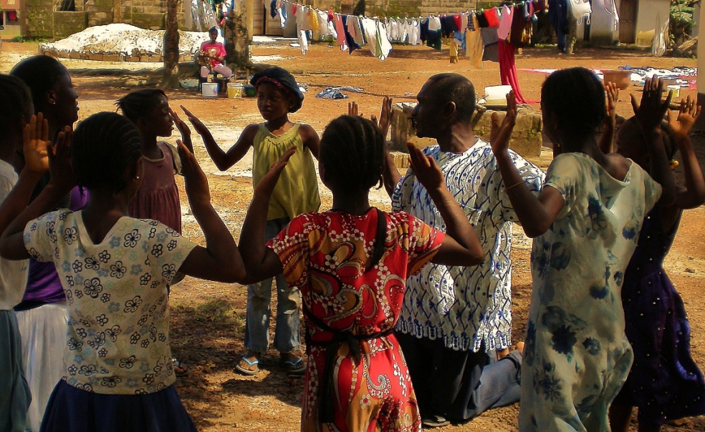
These plans have already manifested in real community initiatives. Within the first 3 weeks we had reports coming in from 3 groups that have started in the inner city of Monrovia. A children’s camp was also run using the material. Several groups have begun in the suburb areas and 3 different groups of trainees have met together in their separate locations to take action in partnership. Four different sites have been visited by the IST to encourage and coach trainees as they implement what they have learned. The IST coordinator says that small group facilitators are requesting a template for report writing because they would like to send in more information about the groups and activities in which that have used the training already.

Challenges
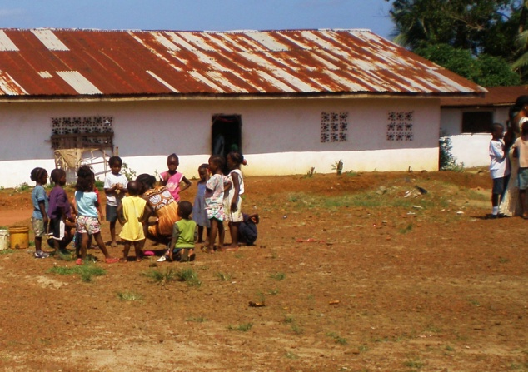
The training was done during the rainy season. This was a significant challenge to the trainees most of whom were coming by motorbike or walking and the rain was extremely heavy. Though this posed a challenge there were some advantages as well, local schools and universities were on Summer Break which meant school teachers, principals and university students could attend the training without interruption or concern. Also, children were readily available in the community for trainees to conduct practical sessions; they would have been in school during other times of the year. In addition to this it was significantly cooler than other seasons and this assisted with the stamina and focus of both trainees and facilitators. An additional challenge was the cost of transport. A solution to this could have been attempting to hire a bus and set-up certain central stops to pick-up trainees. As it was we were able to locate some last minute funding and reimburse some of the trainees who were really struggling with the cost of transport on the final day of the training. Those in greatest need were determined by the IST and funds distributed with quietly and with great sensitivity. We were informed several days into the training that Liberians feel about rain in the same way others might feel about snow in colder climates and rarely travel at all in the rain, even refusing to go to their places of employment. As inconvenient as it was, the rain also gave us the opportunity to see the high level of commitment put forth by the trainees as nearly all were present everyday to despite the weather.
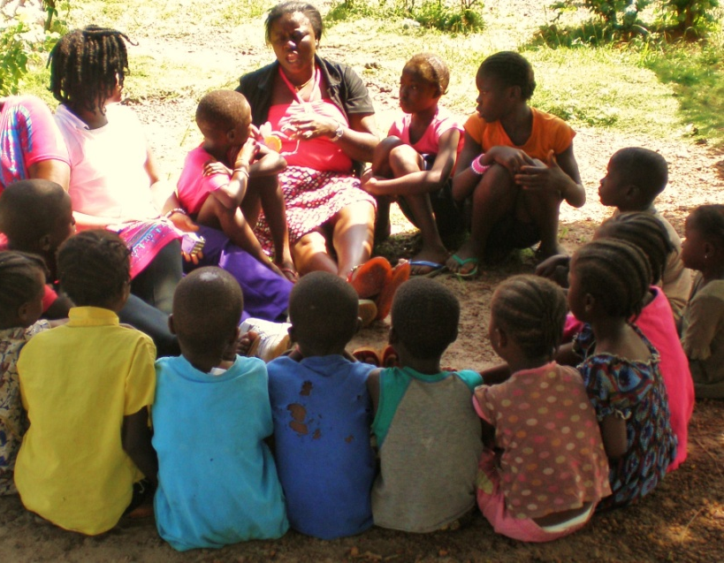

Budget
Before going we were only able to raise half of what we had originally hoped to for the project. Going in we knew that things would be extremely tight. There were several significant unforeseen costs that we are currently still attempting to recover from. Three of the flight tickets had been purchased on Nigerian Airways and they were closed down just days before our flight. The company did not inform passengers appropriately and so we were left to purchase replacement flight tickets from Accra to Monrovia same day. This expense was significant and there has been no reimbursement from Nigerian Air. Additionally, though the training venue was approximately 15 km away from our place of accommodation it took approximately 1.5 hours to travel there each day due to traffic, this also increased what we had anticipated paying in petrol each day. For future projects much more detailed discussions will need to take place and further emergency buffers included for unforeseen costs.

Application Process
Though there was an application form distributed 8 weeks prior to the training, there was not proper follow-up to ensure these were completed and the selection process was complete prior to the training team arriving. This was not the original plan as discussed with the in-country partners and far from ideal for many reasons. Though we were able to ultimately conduct a successful selection process, it was not done at the proper time and so resulted in an increased sense of rejection for those applicants not accepted and cut into the training time by 4 hours.

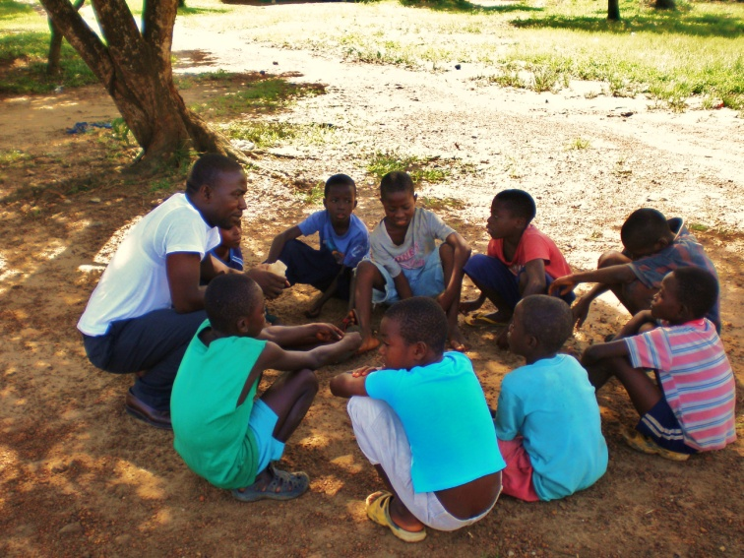
Points for Learning

In addition to the learning that came out of the challenges above, below are more key points for learning.
- A quality selection process is critical to success. Screening must be completed in a thorough fashion, with all trainees selected and attendance confirmed no later than one week prior to the training.
- Budget details must be itemized more clearly and allocation of funds confirmed in a detailed partnership agreement that included phone discussion with local decision makers, not a proxy.
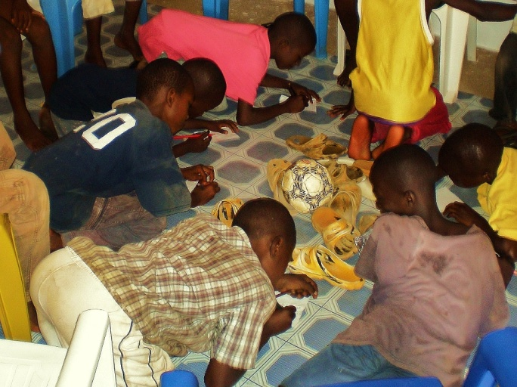
- The development of a committed and quality local IST will be the determining factor in which locations funding is sought for first.
- The IST must be complete and members screened via phone/skype call as a prior to looking for project funding. Local partners who are able to achieve this demonstrate the sincerity and seriousness of their intention to partner well in a sustainable WHH process.
- Enhanced Training for IST is vital, the training schedule must be revised to include a two-day orientation and training for IST members prior to the larger WHH training and at least one half-day debrief with the IST post-training. Many of the trainees requested materials to help them run their support groups. Items such as crayons, glues, stationary and scissors were not always easy to acquire. WHH did leave a kit for each location to share consisting of basic supplies, but it is clear that trainees would feel blessed and further equipped if each of them were able to have a more formal and more thoroughly supplied kit.

Next Steps
- Continued support, communication and resourcing of the Liberian IST team as they follow-up and support the trainees to implement/use the new skills and material. Preparation for the certificate ceremony and reunion dinner for trainees. Stay connected and aware of all post-training needs.
- Develop training teams and a local IST around current partners in Kayelitsha, Uganda and Pakistan.
- Mentoring the point people currently volunteering to organize the process and contacts for the IST in Uganda and Kayelitsha. Provide more detailed expectations.
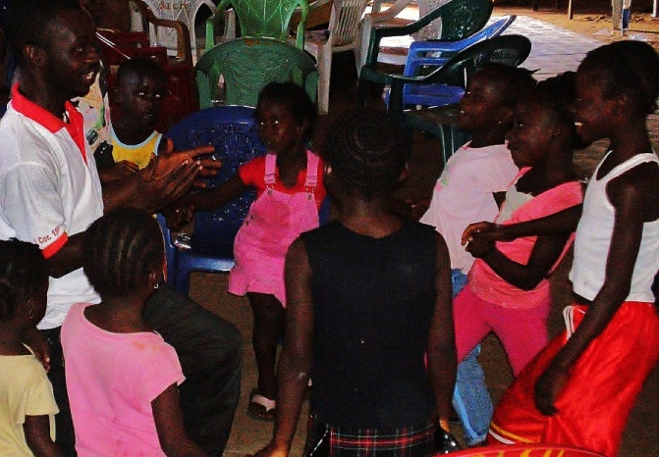
- Revise the curriculum and training program, enhancing/ improving based on learning gleaned from Liberia and continued research.
- Write up a more detailed IST development procedure/process, creating clearly defined roles and pre-process expectations/tasks for the local IST.
- Grow the WHH training team through local and international partnership.
- Create marketing materials and proposals aimed at finding funds to initiate a process in countries that have recently requested the project (Uganda, Pakistan).

