**Out Side Angkor Area Tour**

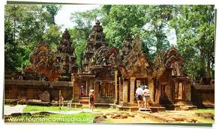

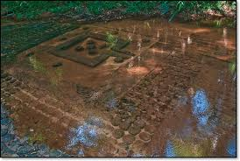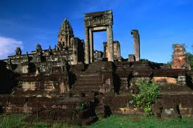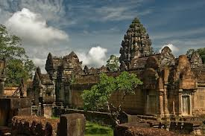Go out of Angkor Area around 37km to Visit the **Banteay Srei** (Citadel of Women), only one temple was decoration carved in pinkish sandstone that cover the wall like tapestry. Next, vist to the thousand lingas of **Kbal Spean** with waterfall as well. On the way back stop at **Banteay Samre,** Many of the carvings are in excellent condition. Continue to Rolous Group, an ancient center of khmer civilization known as Hariharalaya. There are Three temples, **Bakong** received additions and was expanded by later kings. The uppermost section and tower may have been added as late as the 12th century AD. **Lolei** consists of four brick towers on a double laterite platform. It was the last major temple built at Roluos before Yasovarman I moved the capital to the Angkor area.**Preah Ko** (Sacred Bull) derives its name from the statues of bulls at the front of the central towers.

**Price include:**

* English Speaking Driver
* Comfortable air-con transportation/ Tuk Tuk
* Cold towel with Drinking Water during tour

**Price Exclude:**

* Temple Ticket ($20/pax)
* Personal Expense
* Other expense not mentioned in the itinerary