Special package 2 day 1 nights

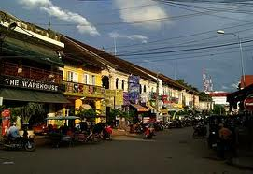 | Day 1: Welcome to Siem Reap City (D)  AM: Warmly welcome by our tour guide and driver, then send you to hotel for check in
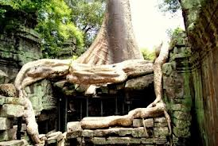    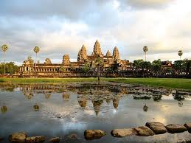  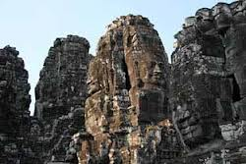 | It’s time to start to visit the Ancient Khmer temple. South Gate of Angkor Thom, Bayon, is one of the most popular sites in the Angkor complex. It was built in the late 12th and early 13th centuries by king Jayavaman VII. Over 200 large faces caved on the 54 towers, represent the 54 provinces in Cambodia. Baphuon,is a single mountain sanctuary situated on a high base symbolizing Mount Meru. Phimean Aksa was the temple where the king worshipped. Terrace of Elephant, the main attractions is the façade decorated with elephant and their ridders depicted in profile. Taprom is the jungle temple. It is very good for your photo because of there are many big roots of giant trees scrap it structure. It is so amazing actually.  Have Lunch at Restaurant & Enjoy shopping at the old Market  Afternoon, Visit to the seven wonder of the world of Angkor Wat. It is a biggest temple in Angkor complex. According to Coedes, is a replica of the universe in stone and represents an earthly model of the cosmic world. Enjoy sunset at Phnom Bakeng  Enjoy buffet dinner with Khmer Ancient traditional Show.
Day 3: Siem Reap – Departure (B)

AM: After breakfast at hotel, then depature to airport or bus station.

End Service

Price include:

- Accommodation ( Twin sharing room with Daily Breakfast)
- English License Tour Guide
- Comfortable air-con transportation with Safety driver/Tuk Tuk
- Cold towel with Drinking Water during tour
- Meals as state above

Price Exclude:

- Temple Ticket ($20/pax)
- Personal Expense
- Cambodian Visa
- Other expense not mentioned in the itinerary

