**Daily Tour in Small Circuit**

**Siem Reap City – Temple complex,**

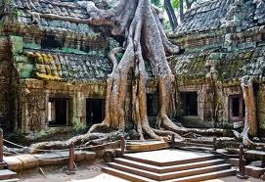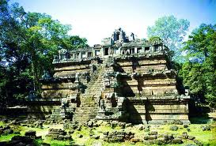**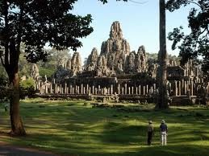AM:** Pick up from your hotel, It’s time to start to visit the Ancient Khmer temple. South Gate of Angkor Thom, **Bayon**, is one of the most popular sites in the Angkor complex. It was built in the late 12th and early 13th centuries by king Jayavaman VII. Over 200 large faces caved on the 54 towers, represent the 54 provinces in Cambodia. **Baphuon**,is a single mountain sanctuary situated on a high base symbolizing Mount Meru. **Phimean** **Aksa** was the temple where the king worshipped. **Terrace of Elephant,** the main attractions is the façade decorated with elephant and their ridders depicted in profile. **Taprom** is the jungle temple. It is very good for your photo because of there are many big roots of giant trees scrap it structure. It is so amazing actually.

Have Lunch at Restau ra nt by your own

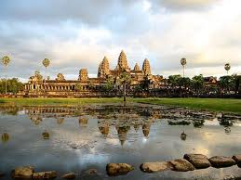Afternoon, Visit to the seven wonder of the world of **Angkor Wat**. It is a biggest temple in Angkor complex. According to Coedes, is a replica of the universe in stone and represents an earthly model of the cosmic world. Enjoy sunset at Phnom **Bakeng.**

**Price include:**

* English Speaking Tour Guide
* Comfortable air-con transportation
* Cold towel with Drinking Water during tour

**Price Exclude:**

* Temple Ticket ($20/pax)
* Personal Expense
* Other expense not mentioned in the itinerary