**Silk Farm**

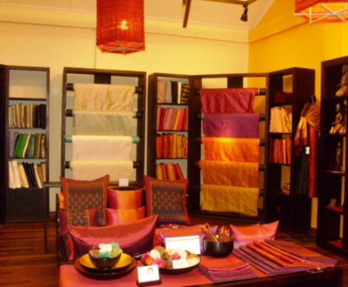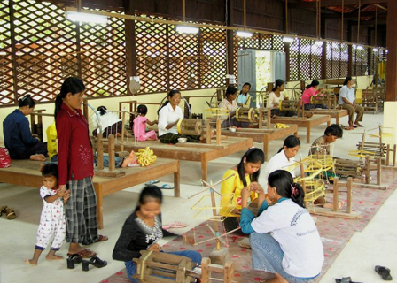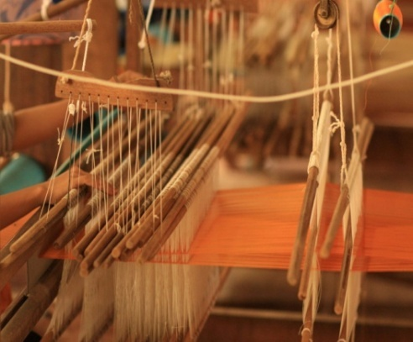Silk weaving was introduced to Cambodia back in the 13th century. Today this is practiced by women in rural villages who still use traditional looms set up below their stilted houses. At the Angkor Silk Farm, you can see the production of hand woven silks, created using the traditional ‘ikat’ method. Here visitors can see the entire process of producing silk, right from the growing of mulberry leaves, its harvesting and breeding of silk worms. The spinning of silk from cocoons and the dyeing process are also very interesting to watch. The silk farm is located 15 kilometres west of Siem Reap. You can indulge in some silk shopping too at the farm.

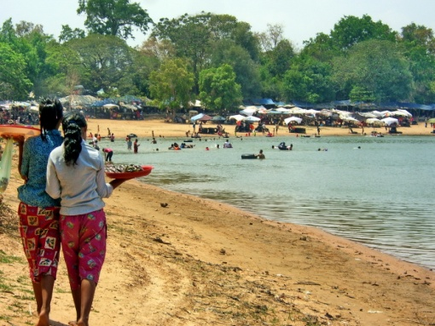**Western Baray**

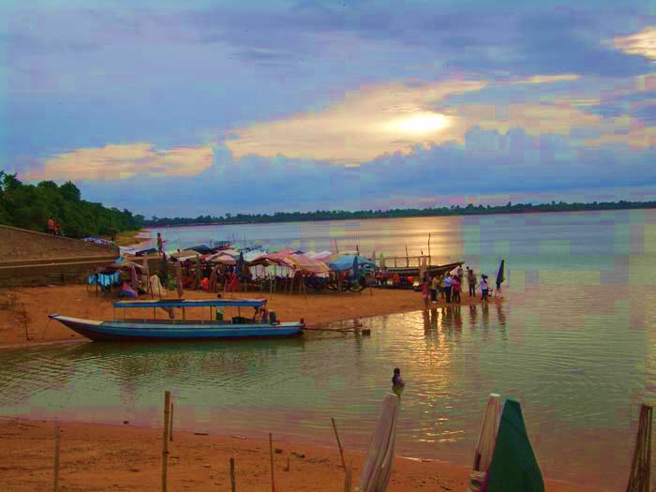The West Baray is a [baray](http://en.wikipedia.org/wiki/Architecture_of_Cambodia" \l "Srah_and_baray" \o "Architecture of Cambodia), or reservoir, at [Angkor](http://en.wikipedia.org/wiki/Angkor), [Cambodia](http://en.wikipedia.org/wiki/Cambodia), oriented east-west and located just west of the walled city [Angkor Thom](http://en.wikipedia.org/wiki/Angkor_Thom). Rectangular in shape and measuring approximately 7.8 by 2.1 kilometers, the West Baray is the largest baray at Angkor. Its waters are contained by tall earthen dikes. In the center of the baray is the [West Mebon](http://en.wikipedia.org/wiki/West_Mebon), a Hindu temple built on an artificial island.you can enjoy swimming there.

**Price Include:**

-Drinking Water

-Transportation