**Beng Mealea & Rolous Group**

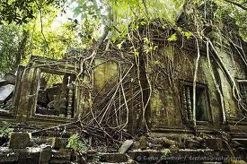

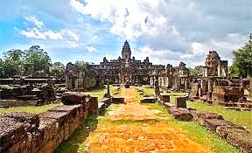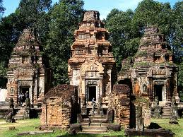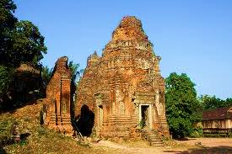**Beng Mealea** Temple, is located 63km east of town. Sprawling jungle temple covering over one square kilometer. The temple is largely overrun by vegetation and very lightly touristed, giving it an adventurous, ‘lost temple’ feel. Photographers: trees growing from the broken towers and galleries offer some of the best ‘tree in temple’ shots aside from Ta Prom, **Bakong** received additions and was expanded by later kings. The uppermost section and tower may have been added as late as the 12th century AD. **Lolei** consists of four brick towers on a double laterite platform. It was the last major temple built at Roluos before Yasovarman I moved the capital to the Angkor area.**Preah Ko** (Sacred Bull) derives its name from the statues of bulls at the front of the central towers.

**Price include:**

* English Speaking Driver
* Comfortable air-con transportation/ Tuk Tuk
* Cold towel with Drinking Water during tour

**Price Exclude:**

* Beng Mealea Ticket ($5/pax)
* Angkor Temple Ticket ($20/pax)
* Personal Expense
* Other expense not mentioned in the itinerary